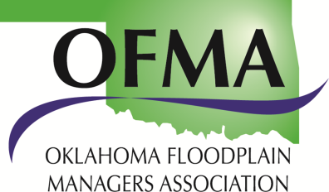

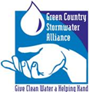
Abstract Submittal Form
Oklahoma Floodplain Managers Association
2020 Stormwater Quality Technical Workshop
Abstracts Due By May 15, 2020
Wednesday, July 15, 2020
Moore Norman Technology Center-Franklin Road Campus
4701 12th Avenue NW, Norman, Oklahoma 73069
Presenter | Click here to enter text.
Company | Click here to enter text.
Presentation Duration | Click here to enter text.
Speaker will be allocated 40 minutes, followed by a 5-minute question/answer period, unless otherwise requested
Presentation Title | Click here to enter text.
Topic
☐ Construction or industrial site inspections and enforcement
☐ Phase I or II MS4 program management, minimum control measures, and case studies
☐ Stormwater quality issues or projects, green infrastructure, watershed studies, and stormwater research
☐ Floodplain management, GIS hydrology and hydraulics
☐ Other: please describe
Abstract
Please describe your presentation in 3-5 sentences.
Please submit your abstract to Carrie Evenson at carrie.evenson@normanok.gov. Selection of speakers will be made by May 29, 2020. You are encouraged to submit topics early to secure your speaking selection. Any questions please call Carrie Evenson at (405) 366-5455.

